|  |  |
| --- | --- |
| **Project ID:**  **PNT2022TMID30001** | **SOLUTION ARCHITECTURE** |

**REAL-TIME COMMUNICATION SYSTEM POWERED** **BY AL FOR SPECIALLY ABLED**

The proposed solution will help convert the sign language into a human hearing voice in the desired language to convey a message to normal people, as well as convert into understandable sign language for the deaf and dumb. 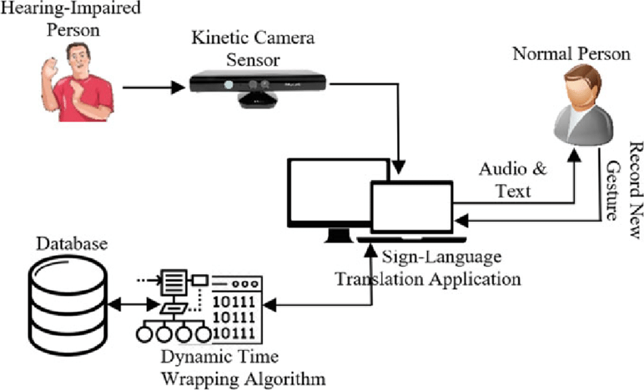

**The architecture of the propose system consists of various blocks:**

**SIGN LANGUAGE DETECTION:**

This is the step that comes right after camera capture. Sign language detection refers to detecting the image that is obtained and, in this case, it is found out if the obtained image is that of a hand or not. A binary classifier is to be trained beforehand to check the same. A binary classifier has the task of classifying sets into two groups, depending on the criteria the sets meet. It checks for one or more qualities that a particular set should possess. It is according to that factor that a binary classifier decided to which group the set should be sent to.

**SIGN LANGUAGE RECOGNITION:**

Sign language recognition is the most crucial procedure of this project. The acquired image is converted to its vector form. The model used is SVM, support vector machine. Support Vector Machine is used to analyze data and classify them. Support Vector Machine comes under supervised machine learning. SVM represents the examples as points in space that are mapped so that they are separated according to the category they come under.

**EVALUATION SIGN LANGUAGE:**

To evaluate the system, both a quantitative and a qualitative evaluation should be performed. One of the major difficulties in performing the evaluation, is that it takes more time for the disabled students to do their course work. Asking them to spend time on the evaluation of a prototype adds a load to their already busy schedule. Nevertheless, as discussed later, a more complete evaluation with several disabled and non-disablity post-secondary students is planned for.

**IMAGE PREPROCESSING:**

Image processing is used to convert an image into digital form and perform certain operations on it to obtain an improved image or extract useful information from it. Preprocessing refers to all the transformations on the raw data before it is fed to the machine learning or deep learning algorithm. For instance, training a convolutional neural network on raw images will probably lead to bad classification performances.

**NLP (NATURAL LANGUAGE PROCESSING):**

Natural language processing refers to the branch of computer science and more specifically, the branch of artificial intelligence or AI, concerned with giving computers the ability to understand text and spoken words in much the same way human beings can. Natural language processing helps computers communicate with humans in their own language and scales other language-related tasks